Machine Learning Coursework:
Churn Prediction for FoodCorp

BUSI4373

Student ID: 20595117

29 May 2025

Note: Report length exceeds page limit due to Title Page and a few large tables that added extra length, but were used solely for the purpose of ease of readability. Please excuse this oversight.

- Executive Summary
FoodCorp has tasked us with performing a pilot study to help them identify potential churners out of their current customer pool. In this specific use case, churn is broadly defined not just as customers who stop shopping with FoodCorp entirely, but those who deviate from their prior behavior patterns in a way that negatively affects the revenue of FoodCorp. Raising customer inactivity and loss of recurring revenue due to customer churn plagues the grocery provider market, and FoodCorp desires the ability to proactively target customers who are likely to churn before they do so. The goal of this project is to provide FoodCorp with a system that, on a weekly basis, can provide a list of customers whose potential for churning (never shopping at FoodCorp again or going from a loyal weekly shopper to a more sporadic low value customer) is high so that FoodCorp can provide targeted marketing and increase customer retention and maintain customer loyalty.

In order to achieve this, an end-to-end churn prediction system was built using transaction level data provided by FoodCorp. This system takes simple customer purchasing data like receipt content, product details, and customer information and can return, with accuracy, a list of currently active customers who are likely to drastically negatively change their spending habits based solely on their historical purchasing information. In order to achieve this in depth insight, many additional temporal and behavioral features were engineered using the data provided to capture traits related to customer loyalty, visit frequency, and engagement measurements.

With these features, a machine learning XGBoost model was trained on training and validation data to predict churn likelihood for customers. A rolling feature window was created to use these features to measure customer behavior trends over time. Using the outputs of this model, a list of the most high-churn-risk active customers is returned to the user. In addition to this list, each potential churner is characterized into one of 3 customer segments which were generated using data clustering techniques. Each potential churner returned is listed as either “Dormant Deadweight”, “Recent Declining”, or “High-Value Lapsed.” Each segment contains customers with largely different spending and shopping habits, as well as different perceived reasons for churning. This additional labeling will help FoodCorp create a more targeted and effective marketing response to the churn problem they are facing.

This model and its output enable proactive customer retention, whereas previously FoodCorp worked on a reactive basis. Additionally, this model supports simple weekly deployment with easily reproducible features and training pipelines.

- Churn
“Churn, in its strictest definition, refers to a customer leaving one company and moving to another.” For the sake of this pilot project, the definition of churn was defined as follows: “A customer is labeled as 'churned' if they made no purchases in the 28 days after the prediction date.” Additionally, in terms of a quantifiable equation, which will be used within the model to identify churners, the following was developed:
If date_today - date_of_last_purchace > β then churn otherwise, not churn (Where β is =28)
The 28 day churn threshold was arrived at through analysis of data provided by ConsultingCorp in conjunction with forward thinking about what would aid the prediction power of the proposed model. In The report, its seen that with a 28 day threshold, about 20% of customers in the current database will be considered churned. Though this creates an imbalanced output class, this provides us with enough churned observations to create a robust model that predicts with good accuracy. Additionally, a 28 window is appealing because it coincides with a month of business which helps keep the report easily digestible and interpretable to any monthly, quarterly, and yearly analysis its insights might be used for within FoodCorp.

This definition of churn fits well with FoodCorps aim to define a length of inactivity that is unacceptable to the company, and therefore makes them willing to attempt intervention. It matches FoodCorp’s interest in loyalty and regularity, and allows for timely intervention with minimal latency. It should be noted that according to FoodCorps wishes, our definition ignores time of day and multiple visits on a single day, and prioritized patter disruption over outright customer exit.

- Churn Prediction System
This section will detail the building of the churn prediction model, and will be explained in chronological order of deployment of the mentioned strategies.

3a. Temporal Strategies
To respect the time-dependent nature of customer behavior and avoid data leakage when looking at future dates, we implemented a fully temporal modeling strategy built around the concept of rolling window strategy.
For each prediction date, we generated features based on customer behavior during the 30-day window preceding the prediction date, and we defined churn labels by checking for 28 days of inactivity after the prediction date. To capture behavioral trends over time, we included lagged windows from 30–60 and 60–90 days before the prediction date, allowing the model to detect changes in frequency, spend, and engagement during the sequential time periods.
Our dataset spans from 22nd July 2020 to 22nd March 2022. We used a chronological split based on the prediction date to create three distinct, forward-looking evaluation sets.
Training: prediction dates before 20th August 2021
Validation: prediction dates from 20th August to 10th September 2021
Testing: prediction dates after 10th September 2021
This strategy ensures that all evaluation simulates real-time deployment, where models are trained on past data and evaluated on unseen future behavior.
To simulate repeated weekly deployment and increase training examples, we implemented a tumbling window approach. Prediction dates were stepped forward in weekly intervals, each producing a new row of features and labels for all active customers at that time. This strategy preserved temporal integrity while enriching the dataset with diverse behavioral snapshots. Additionally, to further avoid data leakage and maintain integrity of the temporal dataset, feature generation and churn labels were always calculated using only data available prior to or at the prediction date. This temporal pipeline formed the foundation for how we created and selected features for churn modeling.
3b. Features
Below is a list of all features that were generated or otherwise provided by the data. Many of these features were subsequently dropped after careful consideration detailed in the feature selection portion of the report.

Feature Name | Written Definition | Technical Definition
days_since_last_visit | Number of days since most recent purchase. | DATEDIFF(prediction_date, MAX(purchased_at))
visits_30days | Total number visits in the last 30 days. | COUNT(DISTINCT receipt_id) WHERE purchased_at BETWEEN prediction_date - 30 AND prediction_date - 1
total_spend_30days | Total spend of customer in the last 30 days. | SUM(receipt_lines.value) WHERE purchased_at BETWEEN prediction_date - 30 AND prediction_date - 1
avg_basket_value | Avg. value per basket over the last 30 days. | SUM(receipt_lines.value) / COUNT(DISTINCT receipt_id)
avg_items_per_visit | Avg. # of items bought per visit in last 30 | SUM(qty) / COUNT(DISTINCT receipt_id)
shop_weekend_pct | % of the visits that occurred on weekends. | 100 * COUNT_IF(DAYOFWEEK(purchased_at) IN (1, 7)) / COUNT(DISTINCT receipt_id)
unique_categories_30days | # of unique product categories purchased in the last 30 days. | COUNT(DISTINCT product.category_code)
most_common_department | Most frequently purchased from departm. | MODE(product.department_name)
customer_age | Customer's age in years at time of prediction. | DATEDIFF(prediction_date, dob) / 365
median_days_between_visits | The median number of days between visits over the last 30 days. | PERCENTILE_APPROX(DATEDIFFs between visits, 0.5)
max_days_between_visits | The max # of days between any two visits in last 30 days. | MAX(DATEDIFFs between visits)
visits_lag1_30days | Total number of visits in the lagged window | COUNT(DISTINCT receipt_id) WHERE purchased_at BETWEEN prediction_date - 60 AND prediction_date - 31
total_spend_lag1_30days | Total spend during the lagged window | SUM(receipt_lines.value) WHERE purchased_at BETWEEN prediction_date - 60 AND prediction_date - 31
unique_categories_lag1 | Number of unique categories purchased in lagged window. | COUNT(DISTINCT product.category_code) WHERE purchased_at BETWEEN prediction_date - 60 AND prediction_date - 31
avg_basket_value_lag1 | Average basket value in lagged window. | SUM(receipt_lines.value) / COUNT(DISTINCT receipt_id)
visits_lag2 | Total number of visits in the second lagged window (60–90 days ago). | COUNT(DISTINCT receipt_id) WHERE purchased_at BETWEEN prediction_date - 90 AND prediction_date - 61
total_spend_lag2 | Total spend in the second lagged window. | SUM(receipt_lines.value) WHERE purchased_at BETWEEN prediction_date - 90 AND prediction_date - 61
unique_categories_lag2 | Number of unique categories in second lagged window. | COUNT(DISTINCT product.category_code) WHERE purchased_at BETWEEN prediction_date - 90 AND prediction_date - 61
avg_basket_value_lag2 | Average basket value in second lagged window. | SUM(receipt_lines.value) / COUNT(DISTINCT receipt_id)
delta_visits | Change in number of visits between current and lag1 window. | visits_30days - visits_lag1_30days
delta_total_spend | Change in total spend between current and lag1 window. | total_spend_30days - total_spend_lag1_30days
delta_unique_categories | Change in product category diversity between current and lag1 window. | unique_categories_30days - unique_categories_lag1_30days
delta_avg_basket_value | Change in average basket value between current and lag1 window. | avg_basket_value - avg_basket_value_lag1_30days
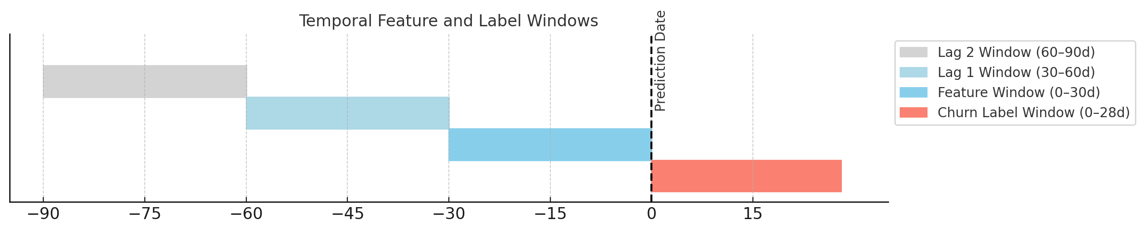
Figure: Temporal Feature and Label Windows
Customer behavior features are calculated from the 30 days before the prediction date, with additional lagged features from the 30–60 and 60–90 day periods. Churn labels are assigned based on inactivity in the 28 days following the prediction date. This structure ensures temporal consistency and prevents data leakage.

3c. Evaluation Strategy
To assess the performance of our churn prediction model, we implemented a time-aware evaluation framework that mirrors how the model would be used in production. We evaluated the model using a chronologically split test set, where training, validation, and testing were separated by prediction date to simulate real-time predictions. This approach ensures that all evaluation reflects forward-looking behavior, using only past data to predict future churn, and strictly avoids data leakage.Our primary evaluation metric was ROC-AUC, as this was an imbalance classification problem. ROC-AUC measures the model’s ability to rank churners above non-churners across all possible thresholds. It plots the True Positive Rate (Recall) against the False Positive Rate, providing a single value (0.5 = random, 1.0 = perfect) to summarize model discrimination. ROC-AUC is particularly useful for ranking customers by churn risk, allowing FoodCorp to focus retention efforts on the highest-risk customers, regardless of the exact cutoff.
Balanced accuracy was our second evaluation metric. Given the imbalanced nature of our churn dataset, where churners are our target and they only represent a minority of the population. It calculates the average of sensitivity (true positive rate) and specificity (true negative rate), ensuring fair performance evaluation across both classes regardless of the imbalance. This metric helps ensure that high accuracy is not simply driven by predicting the majority class.Additionally, we generated learning curves comparing performance across increasing training sizes for both the tuned and baseline models. This helped diagnose issues such as overfitting and underfitting, and confirmed that our regularized XGBoost model generalized well.
3d. Baseline Modelling
To set a baseline score to compare the rest of our more advanced models to, an initial regression analysis was done on a single feature’s effect on the output: days_since_last_visit. With industry knowledge and a general understanding of churn, it is easy to understand that this variable is important and should give some predictive power into a customer’s likelihood to churn. The results are detailed below. The AUC-ROC score was used as the baseline score.

Baseline Logistic Regression (1 Feature)
AUC-ROC Score: | 0.682

3e. Feature Selection
Next, to bring only the most relevant features into the more robust model evaluation, permutation was performed and the least important features were dropped. Permutation feature importance was a strong choice for our churn model because it is model-agnostic and well-suited at capturing non-linear relationships and interactions. Permutation avoids bias toward high-cardinality features and accurately reflects each feature’s true marginal contribution to predictive performance. It also handles both continuous and categorical behavioral data without assumptions about scale or linearity, making it ideal for our diverse feature set. This method helped us identify the most predictive signals of churn and supported feature selection grounded in real model impact.
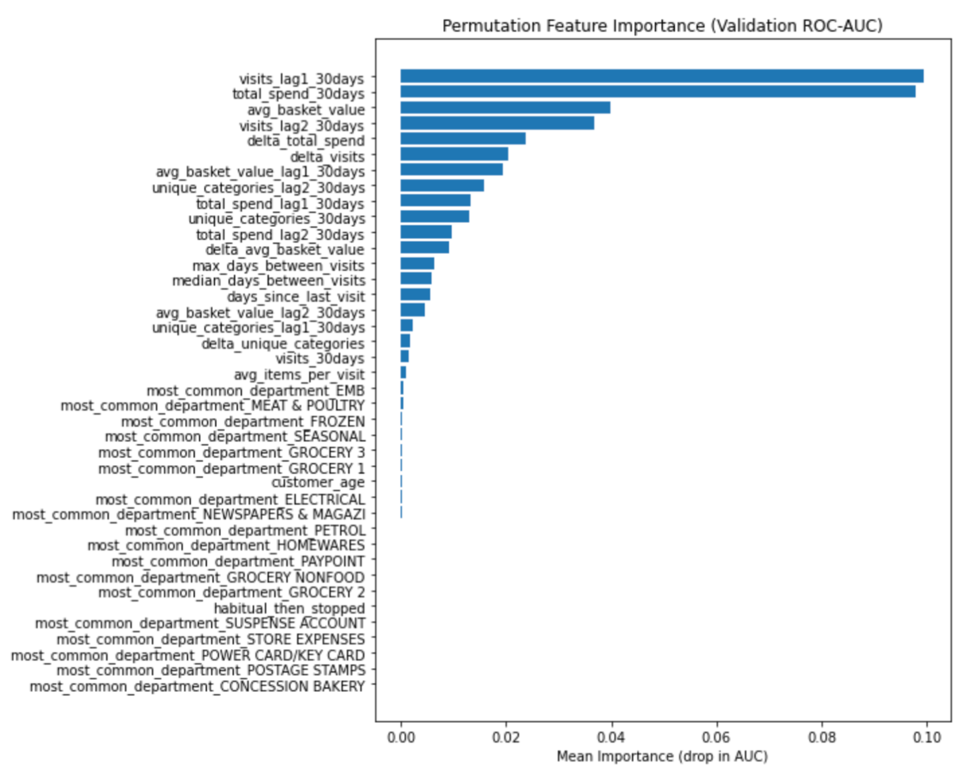
Every feature appearing on the above “Permutation Feature Importance” score list below the feature ‘avg_items_per_visit’ was dropped. Most of these features were ‘most common department’ features that did not aid in predicting churn at all, but two otherwise interesting features were dropped: “customer_age” and “habitual_then_stopped.” Upon further inspection, many of the customer ‘date of birth’ fields were blank, and seeing as there was no way to accurately impute this information the column was dropped from evaluation. Variable “habitual_then_stopped” did not perform well, and the information it holds is covered by combinations of other ‘visit frequency’ variables, so it was dropped from further evaluation.

In order to test the effectiveness of the feature selection, the basic logistic regression model was run again using the train and validation set. This time, it was run with all of the above features, and then again with only the selected features.

Model | Balanced Accuracy | ROC-AUC Score
Logistic Regression (All Features) | 0.597 | 0.682
Logistic Regression (Selected Features) | 0.747 | 0.832

The figure on the left shows the score of the logistic regression that was run on all features, and the figure on the right shows the score of the logistic regression run on just our selected features. By removing noisy, irrelevant, or redundant features, the model trained on selected inputs achieved significantly higher ROC-AUC (+0.15) and balanced accuracy (+0.15). This improvement demonstrates that the selected features offer clearer predictive signals and reduce overfitting, especially in an imbalanced classification task. In particular, permutation-based selection ensured we retained only those variables that materially contributed to the model’s ability to rank churners, making the resulting model both simpler and more effective.

3f. Model Selection
Now that the list of usable features was ready for deployment, model testing was the next logical step. Logistic regression seemed too simplistic for this approach, as the temporal data with lagged features seemed too nonlinear in nature, so XGBoost and Random Forest were tested. Random Forest was much slower, and had a very similar balanced accuracy and slightly lower ROC-AUC score, so XGBoost model was chosen for final model training.

3g. Final Model
The final XGBoost model required little preprocessing to perform well, but hyperparameter tuning was done to ensure that the model was as accurate as possible. A max depth of 3 was chosen to prevent overfitting while still providing for generalization robustness. Regularization was required to prevent overfitting, as can be seen in the learning curve below which shows the models training and validation error scores before and after regularization steps were taken. In order to do this, L1 regularization was applied, as well as choosing a subsample of 80% per tree and a column sample of 80% to introduce some randomness. The number of estimators was set to 300, and the learning rate was set to .05. All of these steps helped to regularize the data and prevent overfitting which was initially observed. No normalization of data was required due to the nature of a tree based model.
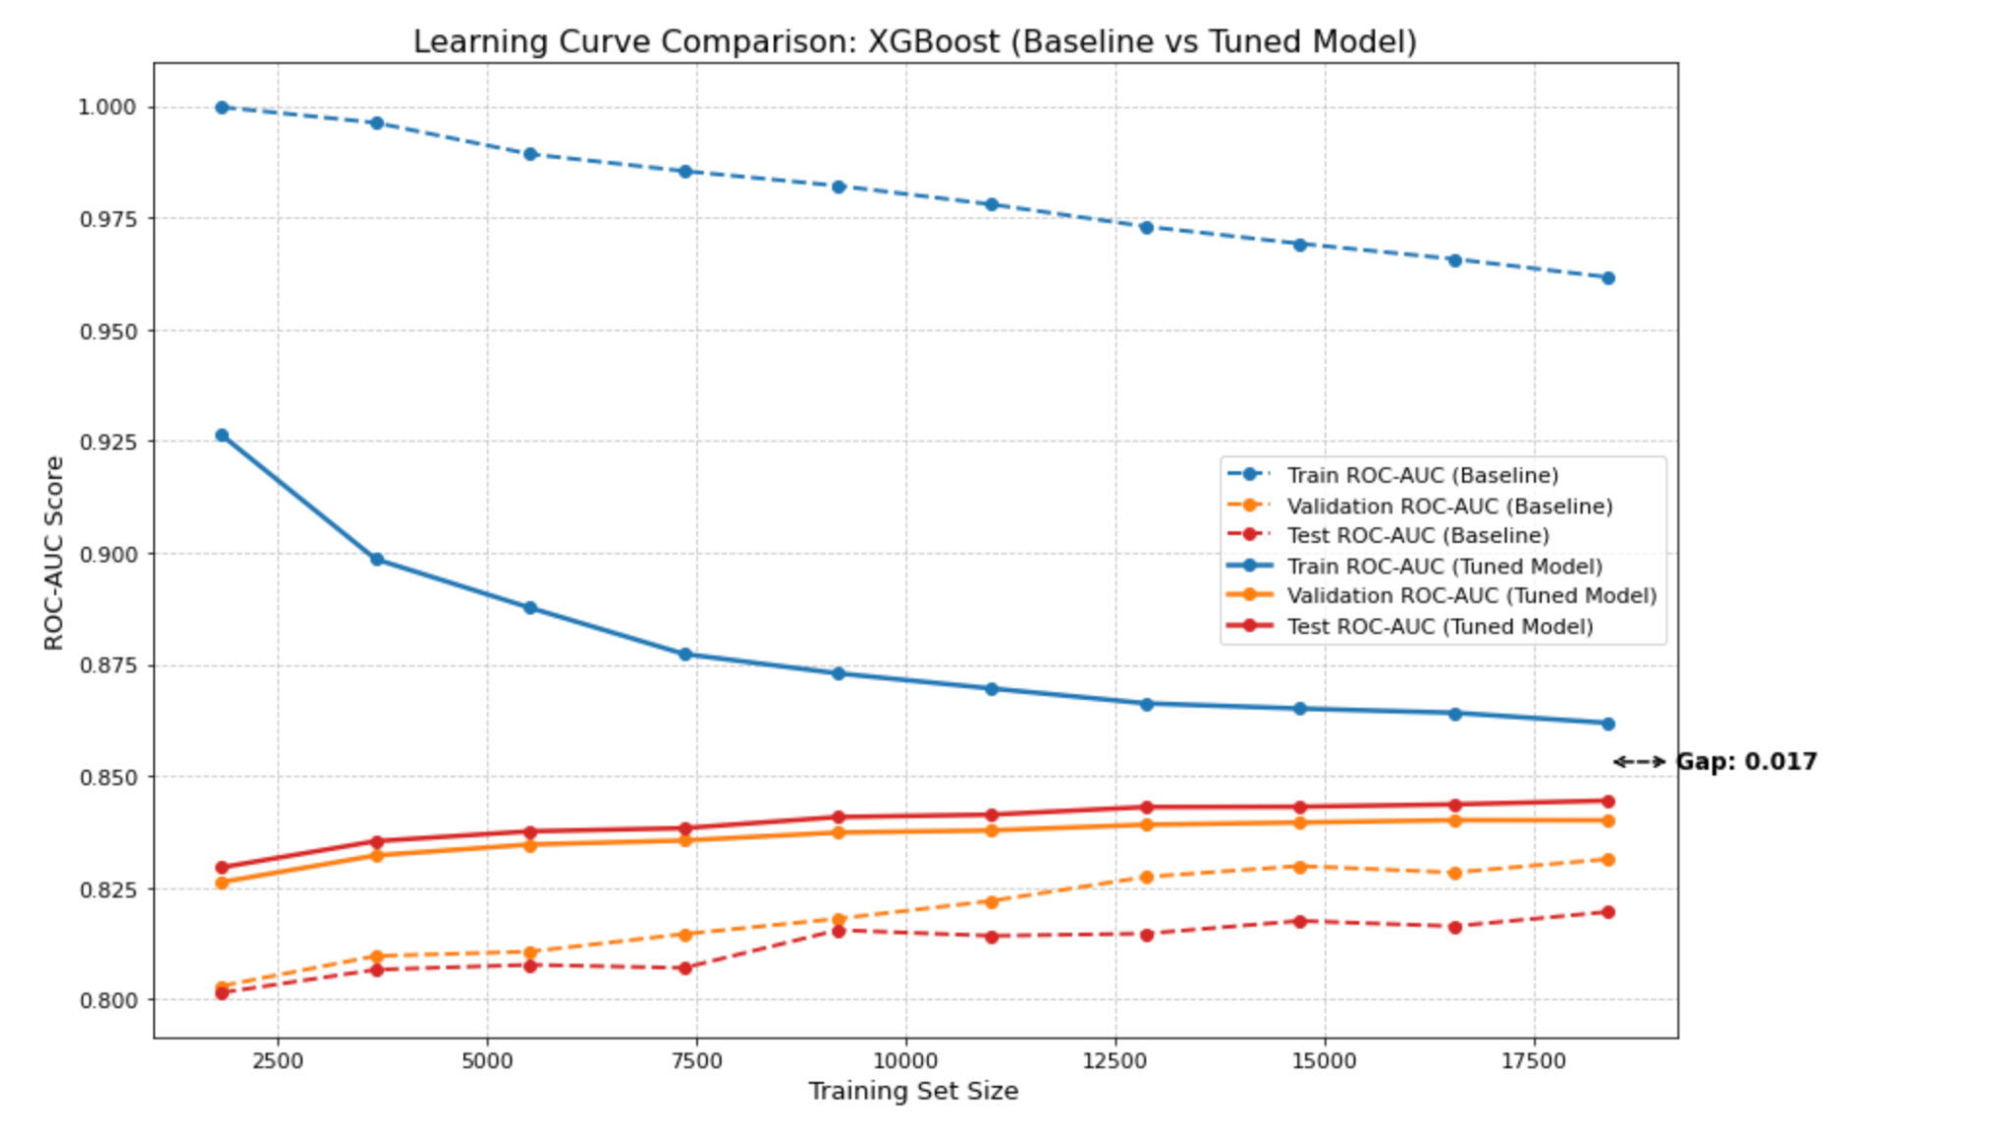

- Summary Evaluation
Our final model performed well on both the training data with the validation set and blindly on the test set as seen in the diagrams below. The slightly improved score on the test set is likely due to the test set having a few hundred more datapoints than the validation set.

Model | Balanced Accuracy | ROC-AUC Score
XGBoost (Validation Set) | 0.749 | 0.840
XGBoost (Test Set) | 0.761 | 0.844

This table presents the performance of our final XGBoost model on unseen data (test set), which simulates real-world predictions. A ROC-AUC score of 0.844 means that 84.4% of the time, the model correctly ranks a randomly selected churned customer higher than a randomly selected non-churned customer. This reflects strong discriminative ability. The balanced accuracy of 0.761 indicates that the model maintains a good trade-off between sensitivity (recall for churners) and specificity (recall for non-churners), even when the classes are imbalanced. Together, these metrics confirm that the model can effectively detect likely churners in new weekly data.

4a. Insight Report for FoodCorp
The analysis revealed clear behavioral differences between customers who churn and those who remain active (full technical outcome of chart can be found below). Churned customers exhibit longer periods of time since their last visit, fewer items per trip, lower overall spend, and narrower product diversity. They also show a lower likelihood of shopping on weekends which can be inferred as a proxy for shopping habit regularity. In contrast, retained customers are more consistent in both frequency and value of engagement, and they purchase from a wider range of product categories.
Using K-means clustering, we segmented churned customers into three distinct groups based on shared patterns of behavior and engagement decline. These groups are outlined below to support targeted retention strategies. Each customer who appears as ‘likely to churn’ in our output will be tagged by which group they are included in, which should make targeted marketing efforts much easier and more effective
Group 1: “Let them Go” - This group is characterized by long gaps of inactivity, and they tend to have the lowest spend and smallest basket sizes. This group has the weakest signs of possible return, and FoodCorp will not realize much upside even if they do return as these are low-value, low-loyalty customers. Their scoring suggest long-term disengagement rather than recent churn.
Group 2: “Recently Declining” - These are customers who were previously recurring and active, but are now reducing visits and spending sharply in the recent monthly periods. They still show moderate-to-high historical value, which means that at one point they were loyal big spenders, but their engagement is reaching a crucial dropoff point. The data suggests that timely, personalized engagement could be effective among this group.
Group 3: “High-Value Lapsed” - These customers displayed the strongest past spending behavior and wide category interest, likely indicating that they did most of their habitual shopping at FoodCorp, but have recently dropped in engagement. Their profile aligns with a very high return on investment upon re-engaging, and the data suggests taht value-driven or loyalty based messaging would be a good approach to win back these high value customers who are likely starting to develop loyalty elsewhere. This is a key opportunity segment.
These insights provide a data-driven foundation for identifying which churned customers are likely to respond to marketing — and which are not. For example, the sharp drop-offs observed in Group 2 indicate that a deeper understanding of why they disengaged could help shape future campaigns.
4b. Technical Report
Our initial results for churned versus non-churned customers were analyzed using simple summary stats and feature important metrics. Comparing the average scores of churned and non-churned customers revealed stark differences, oftentimes in complete opposite directions, for the two groups.
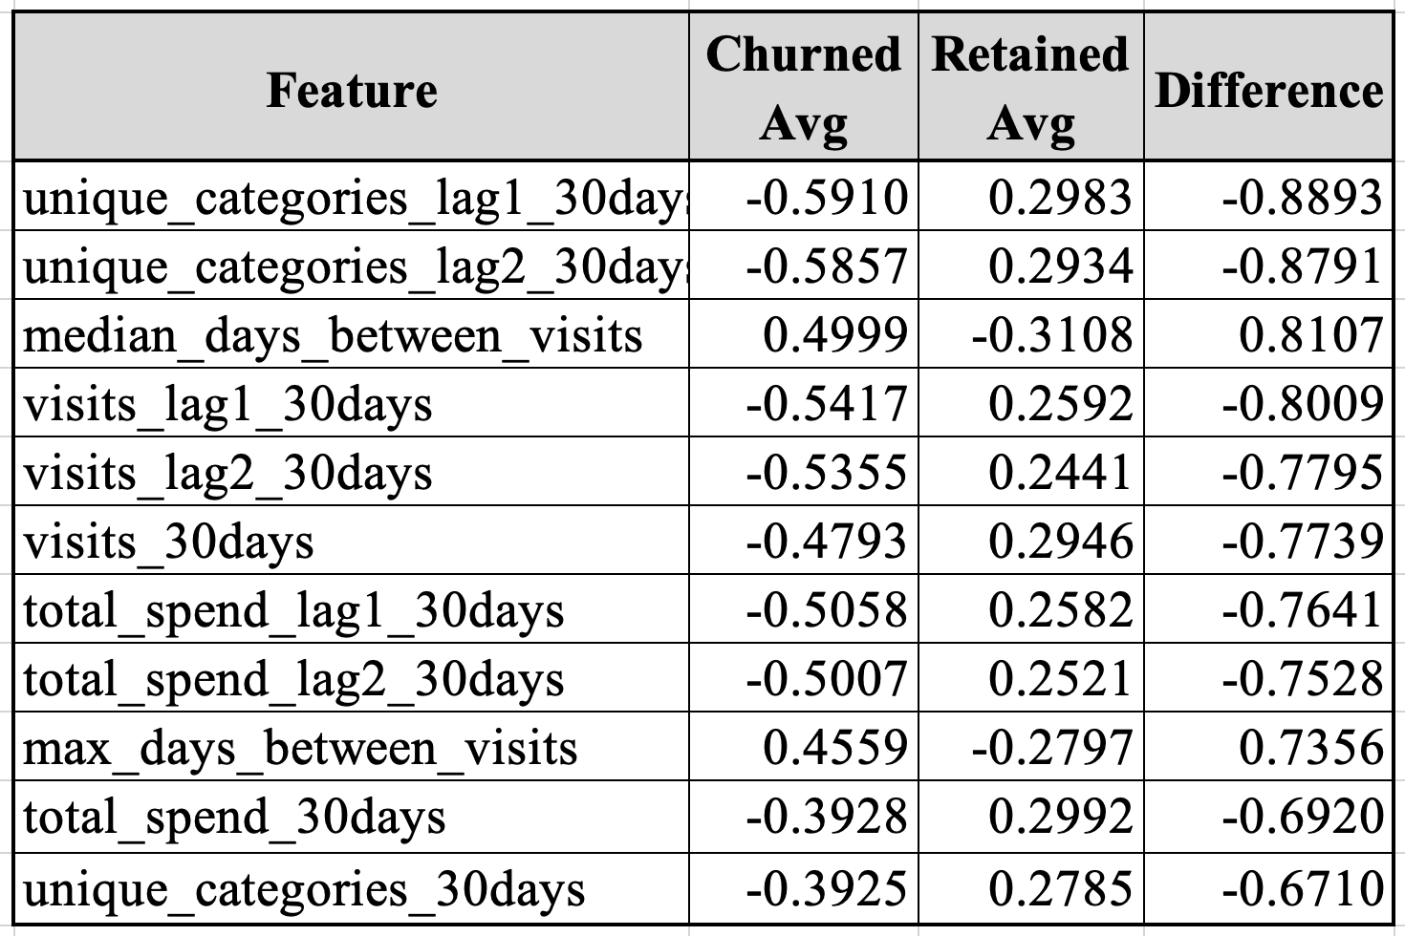
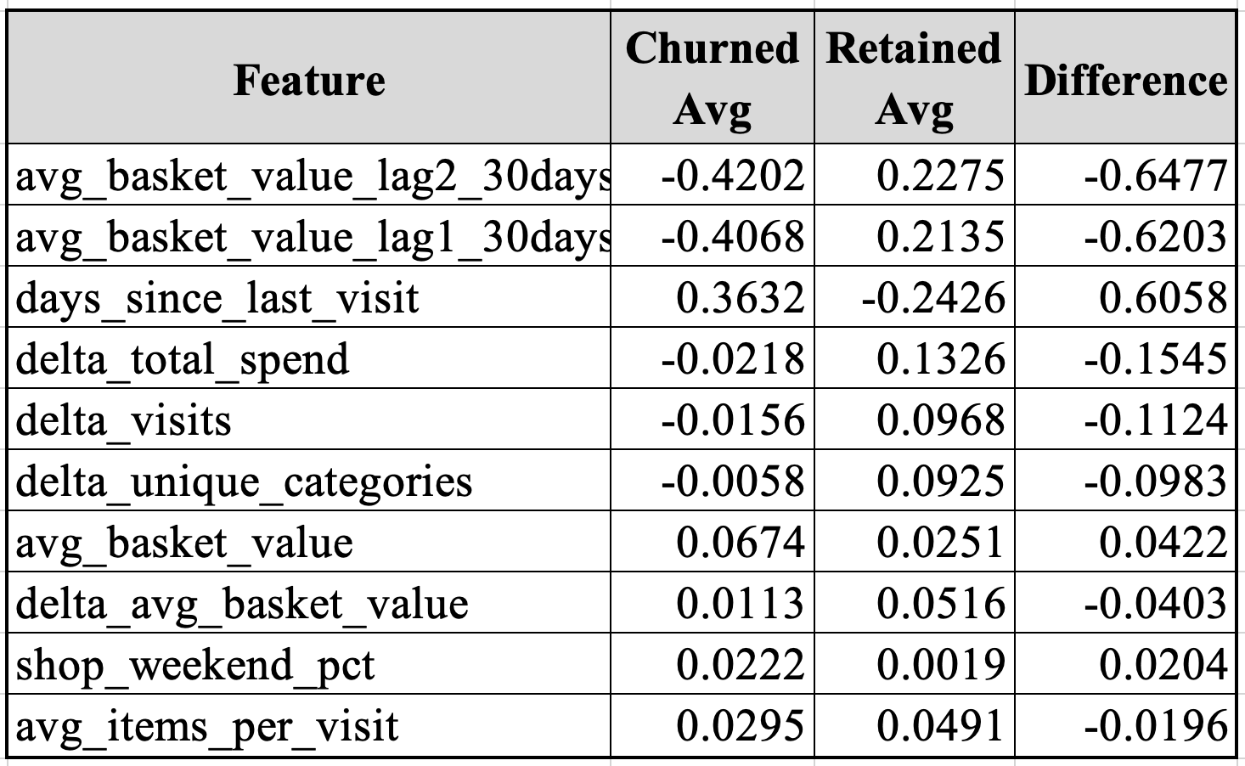

Each score in the churn vs. retained customer table represents the average value of a feature for either churned or retained customers. The “Churned Avg” and “Retained Avg” columns are calculated by taking the mean of each feature within their respective groups. The “Difference” column shows how much higher or lower churned customers score on a feature compared to retained ones. A positive difference means churned customers have a higher value, while a negative value means retained customers do. Larger absolute differences indicate stronger behavioral separation and highlight features most predictive of churn. This comparison is very simple but incredibly effective, and it shows just how different the two groups actually are.

K-means clustering on churned customers was used to uncover natural groupings in behavior. Prior to clustering, all customer behavior variables were standardized using a scaler to ensure comparability. The clustering was performed on the test set churners only, allowing us to focus segmentation on actual cases of churn. We selected K=3 based on a balance of silhouette score and interpretability, with clusters revealing distinct behavioral profiles.

These segments were then profiled based on their average values across key indicators (visits, spend, gaps between purchases, etc.). Segment names and interpretations were generated by ranking features with the highest variance across clusters, which highlighted the behavioral attributes most responsible for the groups’ separation. While Segment 1 showed minimal overall engagement, Segments 2 and 3 displayed meaningful shifts in key engagement indicators — suggesting differing re-engagement potential.

This segmentation, grounded in unsupervised learning, helps link predictive modeling outputs with actionable customer typologies, offering a structured way to understand churn beyond binary classification.
The evaluation began by isolating the test set to ensure that our evaluation was entirely out-of-sample and free of data leakage. Customers were then segmented into churned vs. non-churned groups using our formal churn definition. We computed the mean of each standardized behavioral feature across both groups and calculated the absolute and directional difference between churned and retained customers. This approach enabled the identification of key discriminating variables that were highlighted above.
This analysis was visualized with a sorted bar chart of the absolute group differences, helping to visually flag features with strong behavioral divergence. These variables also overlapped with those deemed most important in permutation-based feature importance, lending further credibility to their role in customer churn dynamics.
To move beyond binary churn prediction and understand the heterogeneity within churners, we applied K-Means clustering to all churned customers in the test set. This allowed us to identify patterns of churn behavior with potential implications for marketing intervention strategies.
Input features were selected from the final XGBoost model pipeline, ensuring consistency with previously validated signals. All features were standardized using ‘StandardScaler()’ to prevent scale bias in Euclidean distance calculations. We used Silhouette Score to evaluate clustering coherence across different values of K (2–9). Although K=2 yielded the highest silhouette score, we selected K=3 as a more actionable compromise that offered better interpretability and marketing differentiation.
After assigning cluster labels to each churned customer, we computed the average value of each input feature per cluster. To determine the most defining features of each cluster, we calculated the feature-wise variance across clusters and ranked features by their maximum inter-cluster spread.
This technical segmentation bridges model output with behavioral understanding. The use of clustering on model-aligned, standardized features allows us to quantify and categorize the nature of churn, providing a principled foundation for business interpretation and action.
This unsupervised learning approach complements our supervised churn prediction model by helping FoodCorp answer not just “Who is likely to churn?” but “What kind of churner are they?” This distinction is critical for targeted retention strategies.

Report for Foocorp. Prepared by Consulting Corp. Provided document

